FOR IMMEDIATE RELEASE

TERRY TO OFFER EXTENDED COLLECTION OF SOPHISTICATED TRANSIT PIECES FOR FEMALE CYCLISTS IN 2016.

Stemming from the success of their 2015 Urban Cycling Collection, Terry will introduce several new additions in 2016.

“The athleisure sportswear trend continues to be a big influence on our new product design. Our customers are wearing their activewear as every-day wear and our products have to be able to adapt accordingly.” – Paula Dyba, VP of Marketing.

Transit Dress:

Deemed as impractical, women have often been discouraged from riding and commuting to work in a dress. In 2016, TERRY will introduce a refined rebuttal to that assumption with the Transit Dress.

FEATURES
Stretchy, wavy-textured Italian fabric UV 50+
Cycling friendly draped neckline
Front placket with slit at center bottom
Shaped hemline, longer in rear
38” center back length
Hidden zip pocket
Relaxed fit

The Transit Dress will be available in sizes XS-XXL, January 2016. Suggested retail $109; made in the USA.

Transit ¾:

A completely new concept in cycling tops, the Transit ¾ has the style of an office-friendly top with distinct details developed for cyclists.

FEATURES
Luxe Italian satin-finished, tonally striped, UV 50+ fabric
Cycling-friendly, wide boat neck top
¾ length sleeves
Tunic-length, shaped hemline, longer in rear
Hidden side zip pocket
Relaxed fit

The Transit ¾ will be available in sizes XS-XXL, January 2016. Suggested retail $89; made in the USA.
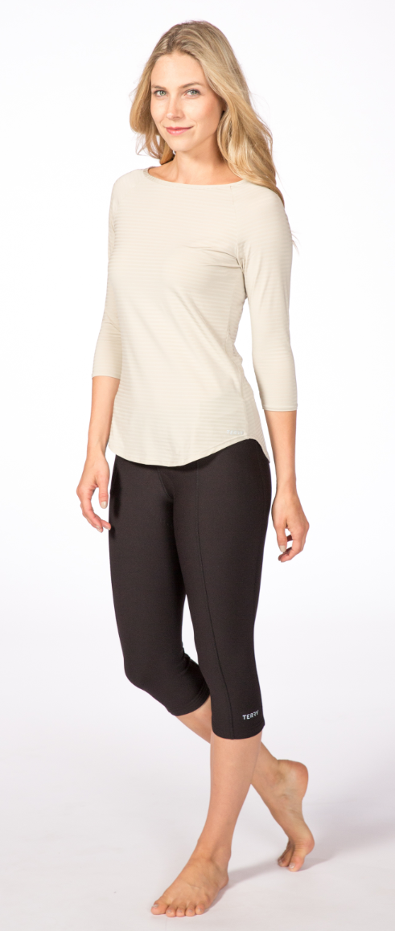
Transit Dress Transit ¾ Top

Cruiser Short:

Developed for the vast majority of women out there who wouldn’t be caught dead in bike shorts, the Cruiser Short is made of natural fiber fabric, has loose-fit legs and a very unobtrusive chamois inside. According to Paula Dyba, VP Marketing,

“ We wanted to offer recreational level and urban cyclists a comfortable option
that doesn’t scream spandex. The new natural fiber based Cruiser Collection looks and feels casual but is definitely featured for riding.”

FEATURES
Cotton-spandex fabric
Pull-on styling with wide elastic waist
Figure flattering rear panel
Loose, tapered legs with 10.5” inseam
Two open rear patch pockets
One zippered leg pocket
Urban chamois

The Cruiser Short will be available January 2016, in sizes XS-XXL; $69 sugg. retail.

Cruiser Skort:

Designed as a feminine alternative for urban riders seeking comfort while on the go – both on and off the bike.

FEATURES
Cotton-spandex fabric
Pull-on styling with extra wide elastic-free waist
Attached liner short (unpadded) with crotch gusset
Crossover front layered skirt with 18” outseam

Available January, 2016, in sizes XS-XXL; $59 sugg. retail.

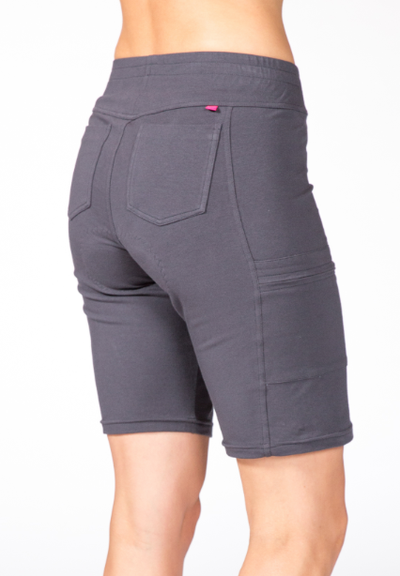
Cruiser Short Cruiser Skort

About TERRY
For over 30 years, TERRY has been dedicated to getting more women riding bikes. TERRY apparel and saddles for both women and men are designed to improve the ride for all levels of cyclists and are distributed by better bike shops and major retailers across the US. From serious gear to recreational fun, TERRY positions itself as a brand for all, where technical performance and feminine style ride in tandem.
For more information, contact:
VP of Marketing, Paula Dyba
paula@terrybicycles.com, 585-415-3849.

