FOR IMMEDIATE RELEASE:

TERRY UNVEILS AN INSPIRED TOUR COLLECTION FOR SUMMER 2016.

This limited edition collection is dedicated to the Tour de France and designed with performance in mind by the Original Women’s Bicycling Company. Integrating sleeveless and sun protective jerseys, printed shorts and matching gloves, these kits are podium-worthy and ready to ride. On the vision for this collection, VP of Marketing, Paula Dyba:

“From Normandy’s Mont-St-Michel through the flower fields of Limoges, the climb up Mont Ventoux to the arrival in Paris, our tribute to the Tour is bright and fierce.”

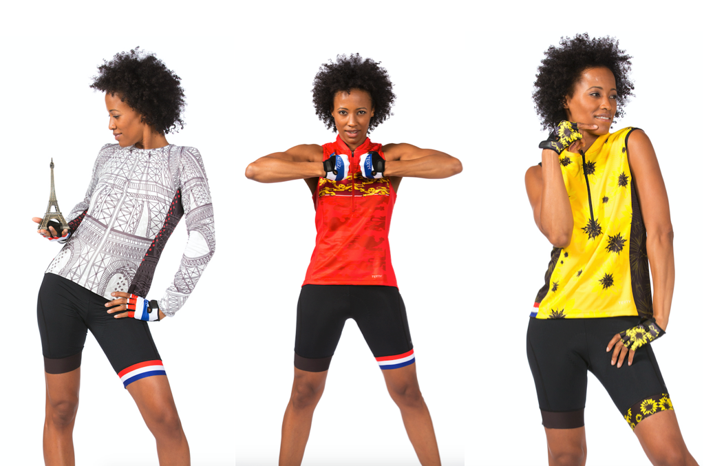

DEPART A L’ARRIVEE: 2016 LIMITED EDITION TOUR COLLECTION.

Sun Goddess Jersey:
Our tribute to the start of the Tour in Normandy is available only in our highly rated Sun Goddess. 10” front zipper; racer back; 2 rear open pockets; wicking fabric with UPF 50+ and anti-odor protection. Made in USA and available in sizes XS-XXL; $65 suggested retail. COLORS: Normandy, Sunflower Dots.

Sun Goddess Jersey - Sun Flower Dots
Sun Goddess Jersey - Normandy

Breakaway Mesh Jersey:
Designed with high viz, high flying, prints – these jerseys reflect everything we love about the Tour. This best-selling jersey is created with fast-wicking fabric, UPF 50+ and anti-odor protection; 10” front zipper; 2 rear open pockets. Made in USA and available in sizes XS-XXL; $65 suggested retail. COLORS: Paris, Stages.

Breakaway Mesh Jersey - Paris
Breakaway Mesh Jersey - Stages

Soleil Top:
Graceful and simply styled, this tribute to the arrival in Paris also limits the harmful effects of sun exposure with lightweight, UPF 50+ protection. Made of micropoly spandex, crew neck styling and 3 open rear pockets. Available in sizes XS-XXL; suggested retail $89. COLOR: Tower.
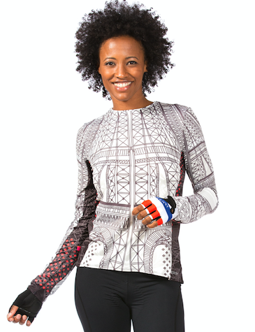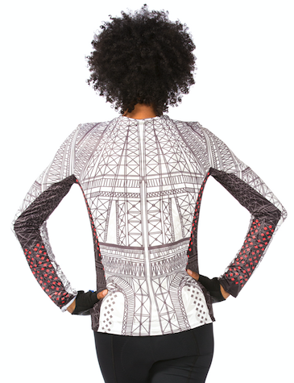
NEW Printed Peloton Short:
Our first-ever, printed bottom features laser cut leg bands with custom Tour inspired printing on the left leg. Designed with the premium Flex chamois, 6 panel construction and premium Italian fabric with moderate compression. Made in the USA and available in sizes XS-XXL; $99 suggested retail. COLORS: Liberty, Sunflower.
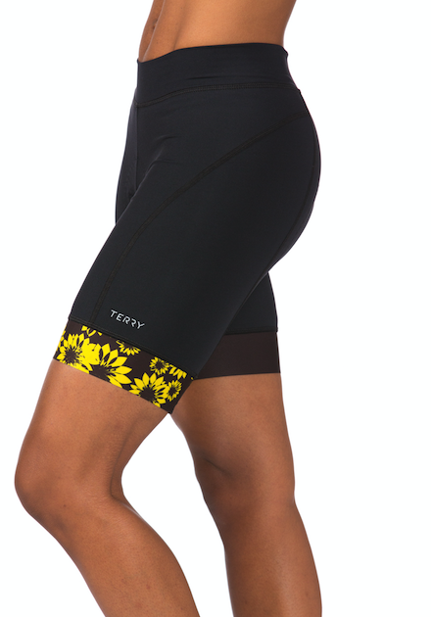
Signature Gloves:
Designed to be super breathable, these gloves feature padded mesh palms, adjustable wrist cuffs, and microfiber thumbs; provide shock protection and a precision grip. Made in Italy and available in sizes XS-L; suggested retail $40. COLOR: Liberty, Sunflower.

The full TERRY Ltd Tour Collection will be available mid April and can be previewed here: community.terrybicycles.com/from-start-to-finish.

About Terry
For over 30 years, TERRY has been dedicated to getting more women riding bikes. TERRY apparel and saddles for both women and men are designed to improve the ride for all levels of cyclists and are distributed by better bike shops and major retailers across the US. From serious gear to recreational fun, TERRY positions itself as a brand for all, where technical performance and feminine style ride in tandem.

For more information, contact:
VP of Marketing, Paula Dyba
Paula@terrybicycles.com, 585-415-3849.

